Set-up new ubuntu 16.04 machine with software and apps

Update app listing

sudo apt-get update

Install git

apt-get install git-core

Install pip

sudo apt-get install python-pip

sudo pip install --upgrade pip==9.0.3 --user
(pip version 10 has issues)

Install Sublime Text
http://tipsonubuntu.com/2017/05/30/install-sublime-text-3-ubuntu-16-04-official-way/

1. Open terminal via Ctrl+Alt+T or by searching for “Terminal” from desktop app launcher. When it opens, run command to install the key:
wget -qO - https://download.sublimetext.com/sublimehq-pub.gpg | sudo apt-key add -
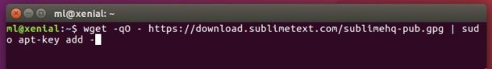
2. Then add the apt repository via command:
echo "deb https://download.sublimetext.com/ apt/stable/" | sudo tee /etc/apt/sources.list.d/sublime-text.list
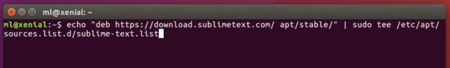
3. Finally check updates and install sublime-text via your system package manager:
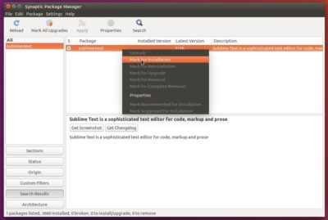
or by running commands:
sudo apt-get update

sudo apt-get install sublime-text
Once installed, launch it from your desktop app launcher and enjoy!

Make Sublime default text editor

https://askubuntu.com/questions/396938/how-do-i-make-sublime-text-3-the-default-text-editor

First, make sure that /usr/share/applications/sublime_text.desktop exists (sublime-text.desktop on some systems):
ls /usr/share/applications/sublime_text.desktop
Then, open /usr/share/applications/defaults.list with Sublime:
subl /usr/share/applications/defaults.list
Search for all instances of gedit and replace them with “sublime_text”. Save the file, log out and back in, and you should be all set.
Reboot system

If for some reason /usr/share/applications/sublime_text.desktop (or sublime-text.desktop doesn't exist, create it:
sudo touch /usr/share/applications/sublime_text.desktop
Open it in Sublime:
subl /usr/share/applications/sublime_text.desktop
and paste the following into it:
[Desktop Entry]
Version=1.0
Type=Application
Name=Sublime Text
GenericName=Text Editor
Comment=Sophisticated text editor for code, markup and prose
Exec=/opt/sublime_text/sublime_text %F
Terminal=false
MimeType=text/plain;
Icon=sublime-text
Categories=TextEditor;Development;
StartupNotify=true
Actions=Window;Document;

[Desktop Action Window]
Name=New Window
Exec=/opt/sublime_text/sublime_text -n
OnlyShowIn=Unity;

[Desktop Action Document]
Name=New File
Exec=/opt/sublime_text/sublime_text --command new_file
OnlyShowIn=Unity;
However, if you installed Sublime Text using the .deb file downloaded from sublimetext.com, the file should already exist.

